25/05/2022 09:16:05

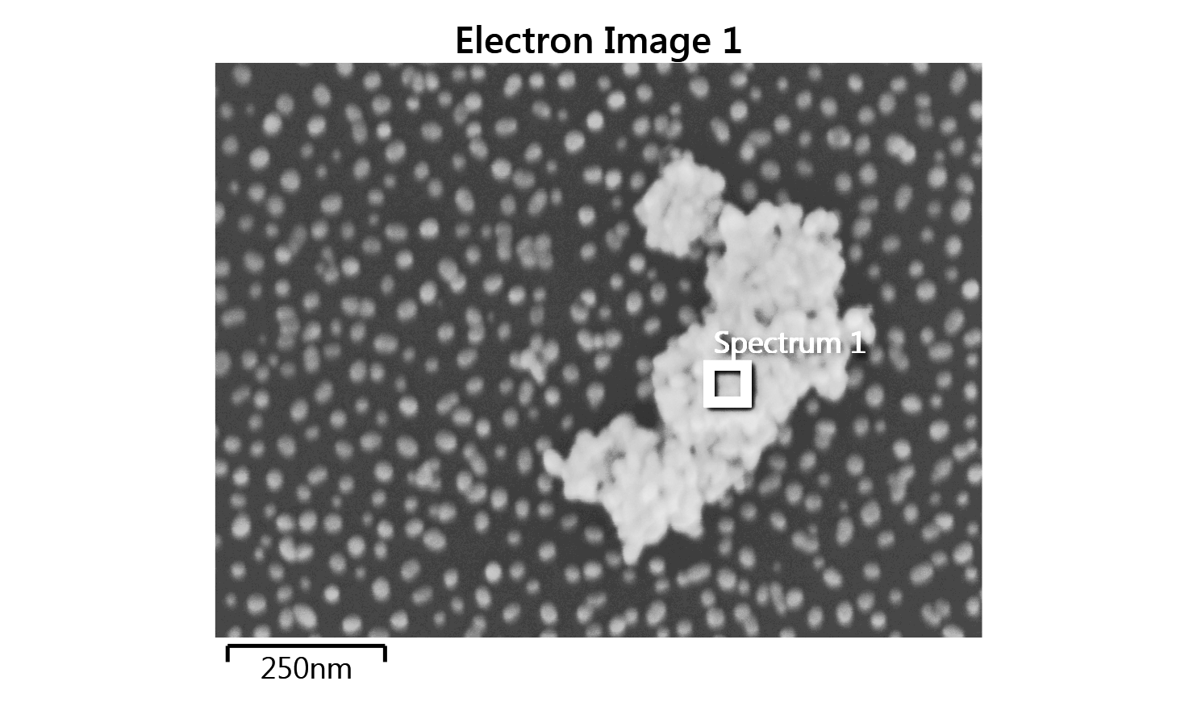

|  |  |
| --- | --- |
| Label: | Electron Image 1 |
| Collected: | 25/05/2022 09:15:19 |
| Input Signal: | SE |
| Resolution (Width): | 2048 pixels |
| Resolution (Height): | 1536 pixels |
| Image Width: | 1.22μm |
| Image Height: | 914nm |
| Stage Tilt Degrees: | 0.00° |
| Specimen Tilt Degrees: | 0.00° |
| Software Tilt Correction: | Not applied |
| Magnification: | 251656 x |
| Number of Averaged Frames: | 1 |
| Dwell Time: | 10μs |

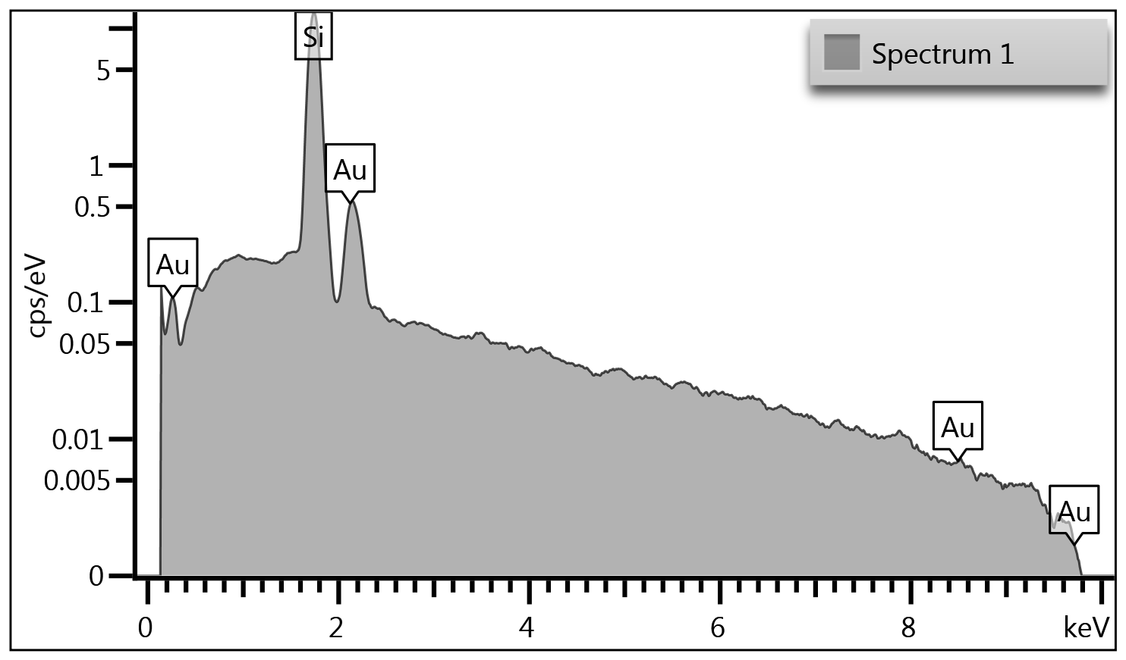

|  |  |
| --- | --- |
| Label: | Spectrum 1 |
| Source: | Acquired |
| Created: | 25/05/2022 09:16:05 |
| Livetime: | 141.7s |
| Process Time: | 4 |
| Accelerating Voltage: | 10.00kV |
| Magnification: | 251656 x |
| Working Distance: | 10.0mm |
| Specimen Tilt (degrees): | 0.0 |
| Elevation (degrees): | 35.0 |
| Azimuth (degrees): | 0.0 |
| Number Of Channels: | 1024 |
| Energy Range (keV): | 10 keV |
| Energy per Channel (eV): | 10.0eV |
| Detector Type Id: | 26 |
| Detector Type: | X-Act |
| Window Type: | SATW |
| Pulse Pile Up Correction: | Succeeded |

|  |  |
| --- | --- |
| Label: | Spectrum 1 |
| Element List Type: | Current Spectrum |
| Processing Option: | All Elements |
| Coating Element: | None |
| Automatic Line Selection: | Enabled |
| Normalization: | Enabled |
| Thresholding: | Disabled |
| Deconvolution Elements: | None |
| Selected Standards: | Quant Standardizations [ Factory ] |
| Pulse Pile Up Correction: | Succeeded |
| Detector file: | x-act 6 |
| Efficiency: | File based |
| Element | Line Type | Apparent Concentration | k Ratio | Wt% | Wt% Sigma | Standard Label | Factory Standard | Standard Calibration Date |
| Si | K series | 4.92 | 0.03898 | 83.70 | 0.42 | SiO2 | Yes |  |
| Au | M series | 0.43 | 0.00429 | 16.30 | 0.42 | Au | Yes |  |
| Total: |  |  |  | 100.00 |  |  |  |  |